CSA 1717-ARTIFICIAL INTELLIGENCE
LAB EXPERIMENTS
Abinaya Sri J(192524429)
AIM
To implement the Breadth-First Search (BFS) algorithm in Python to traverse a graph.
OBJECTIVE
To traverse all the nodes of a graph using the Breadth-First Search (BFS) algorithm. To understand the concept of queue and level-by-level graph traversal.
ALGORITHM
Step 1: Start.
Step 2: Create the graph using an adjacency list.
Step 3: Create an empty queue.
Step 4: Create an empty list to store visited nodes.
Step 5: Insert the starting node into the queue and mark it as visited.
Step 6: Repeat until the queue becomes empty:
- Remove the first node from the queue.
- Print the node.
- Visit all adjacent nodes.
- If an adjacent node has not been visited, mark it as visited and add it to the queue.
Step 7: Stop when all reachable nodes are visited.
SOURCE CODE
from collections import deque

# Graph represented as an adjacency list
graph = {
'A': ['B', 'C'],
'B': ['D', 'E'],
'C': ['F'],
'D': [],
'E': ['F'],
'F': []
}
# BFS Function
def bfs(graph, start):
visited = [] # Stores visited nodes
queue = deque() # Queue for BFS
visited.append(start)
queue.append(start)
while queue:
node = queue.popleft()
print(node, end=" ")
for neighbour in graph[node]:
if neighbour not in visited:
visited.append(neighbour)
queue.append(neighbour)
# Driver Code
print("BFS Traversal:")
bfs(graph, 'A')
FLOW CHART
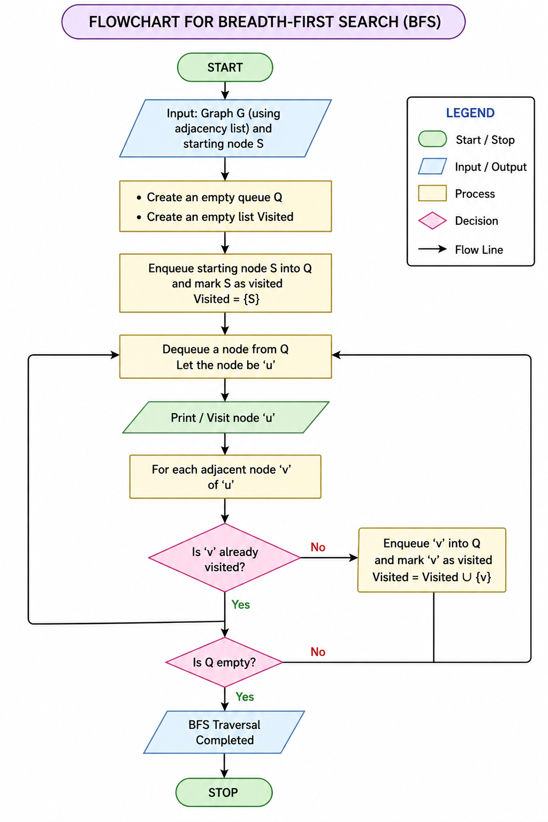
OUTPUT
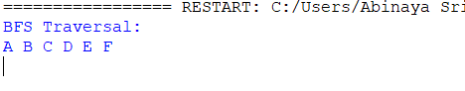
RESULT
The graph was successfully traversed using the Breadth-First Search (BFS) algorithm.

